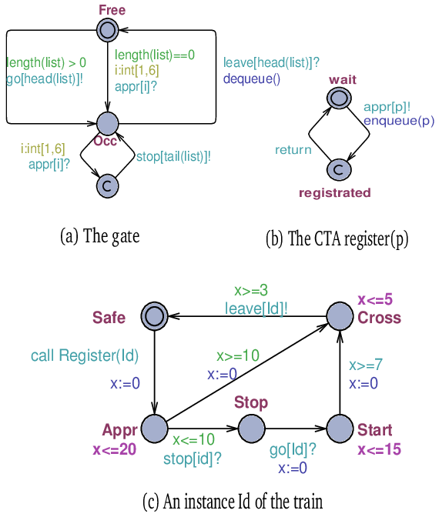

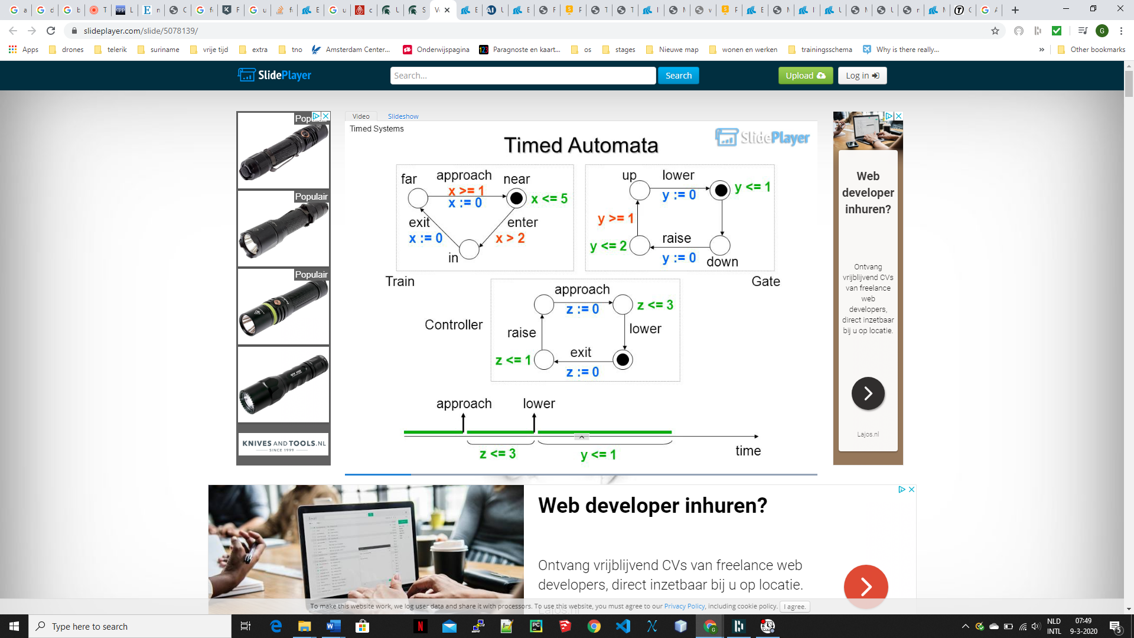

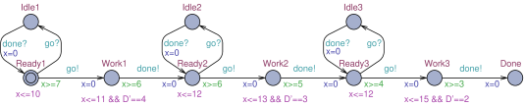

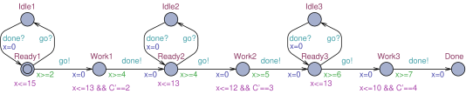

floating point arithmetic

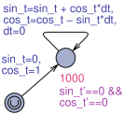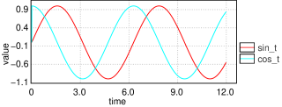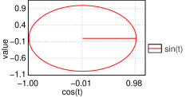

bron: <https://www.groundai.com/project/uppaal-smc-statistical-model-checking-for-priced-timed-automata/1>

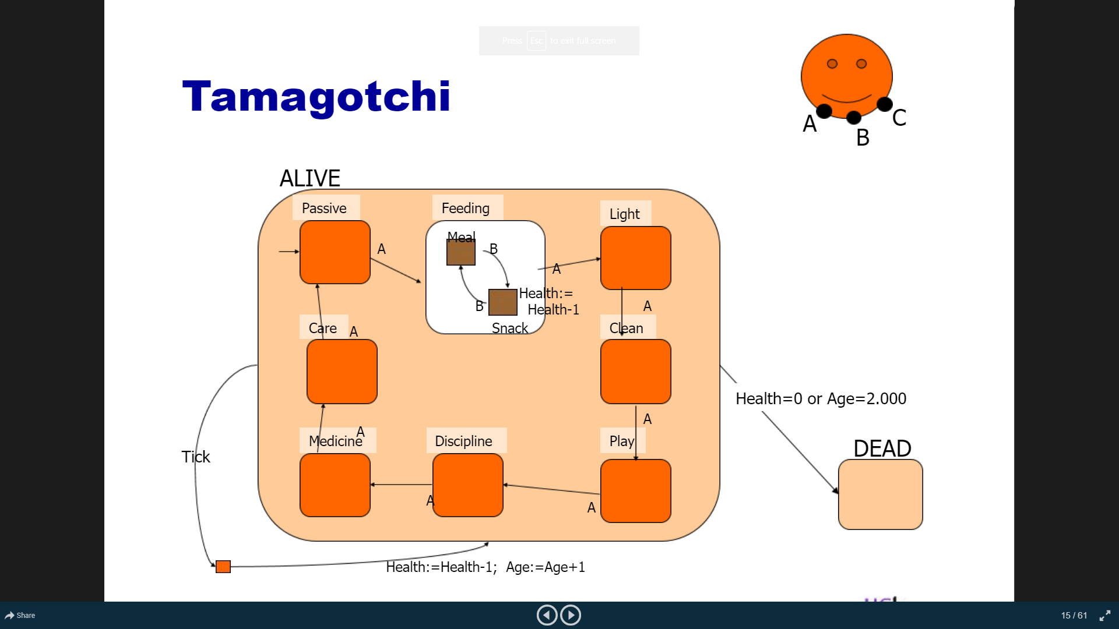

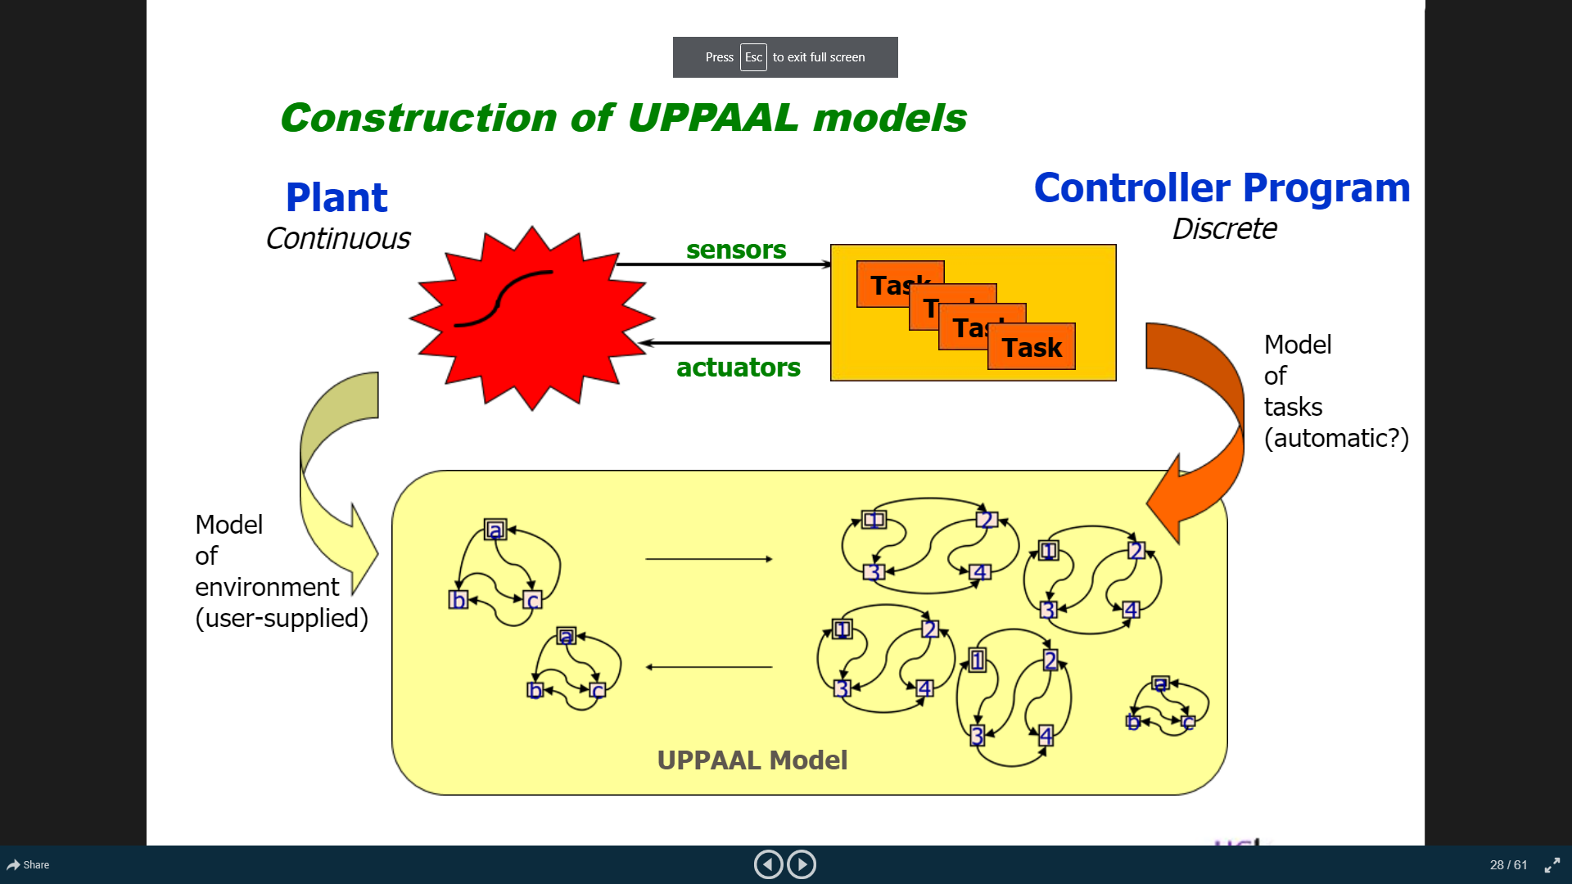

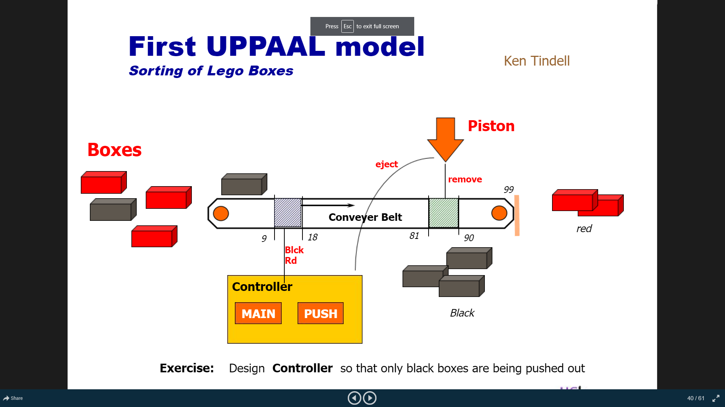

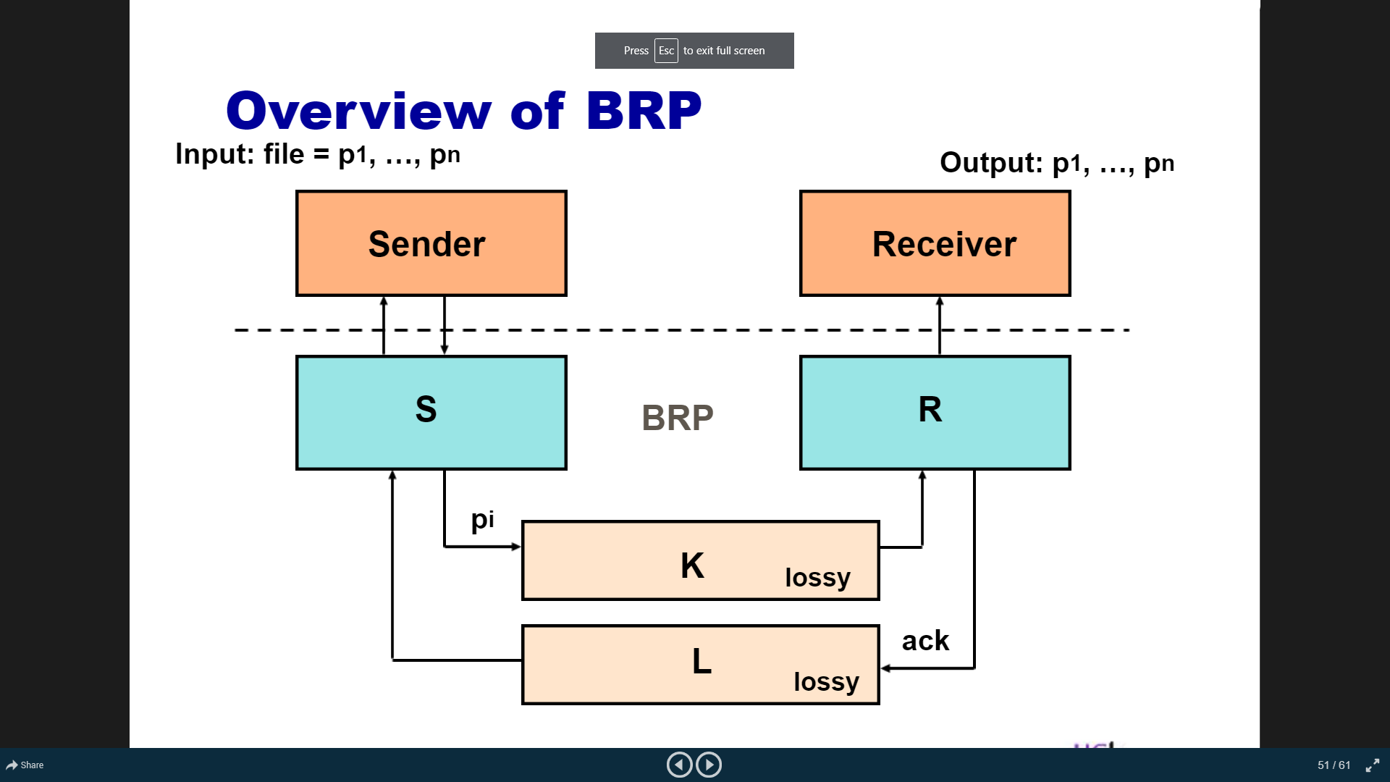

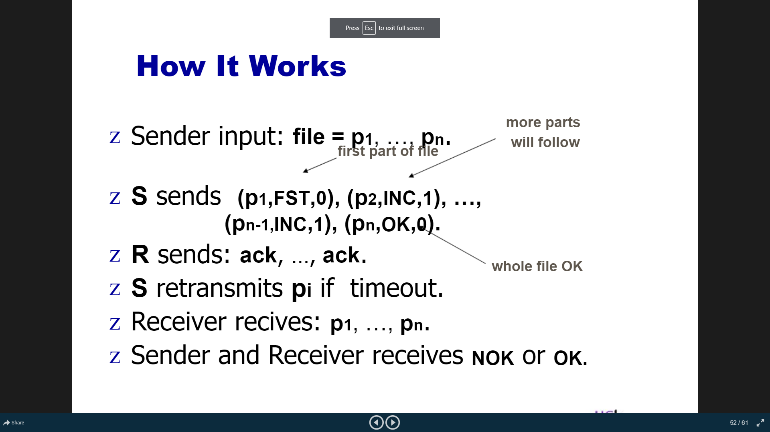

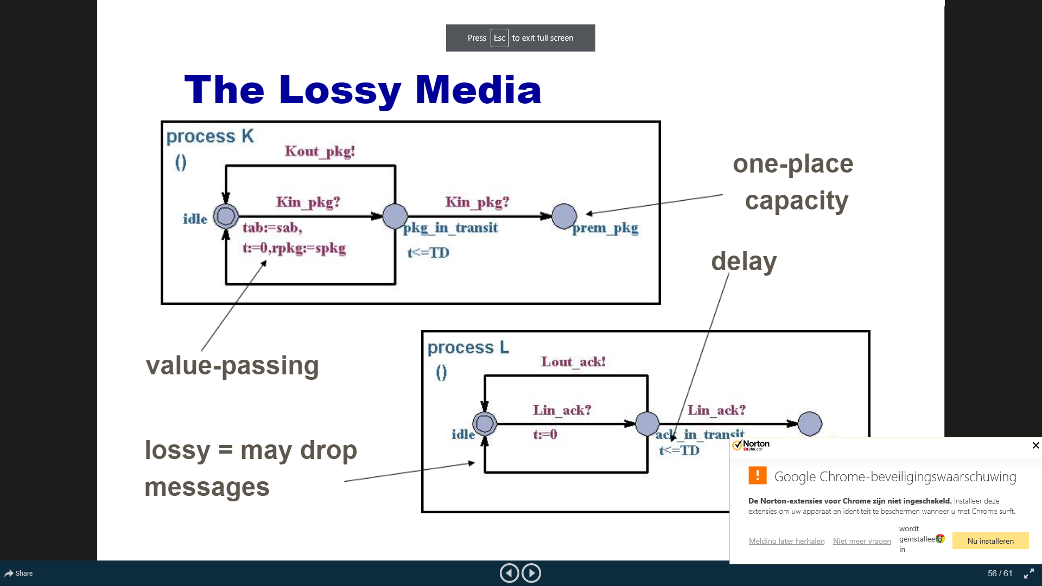

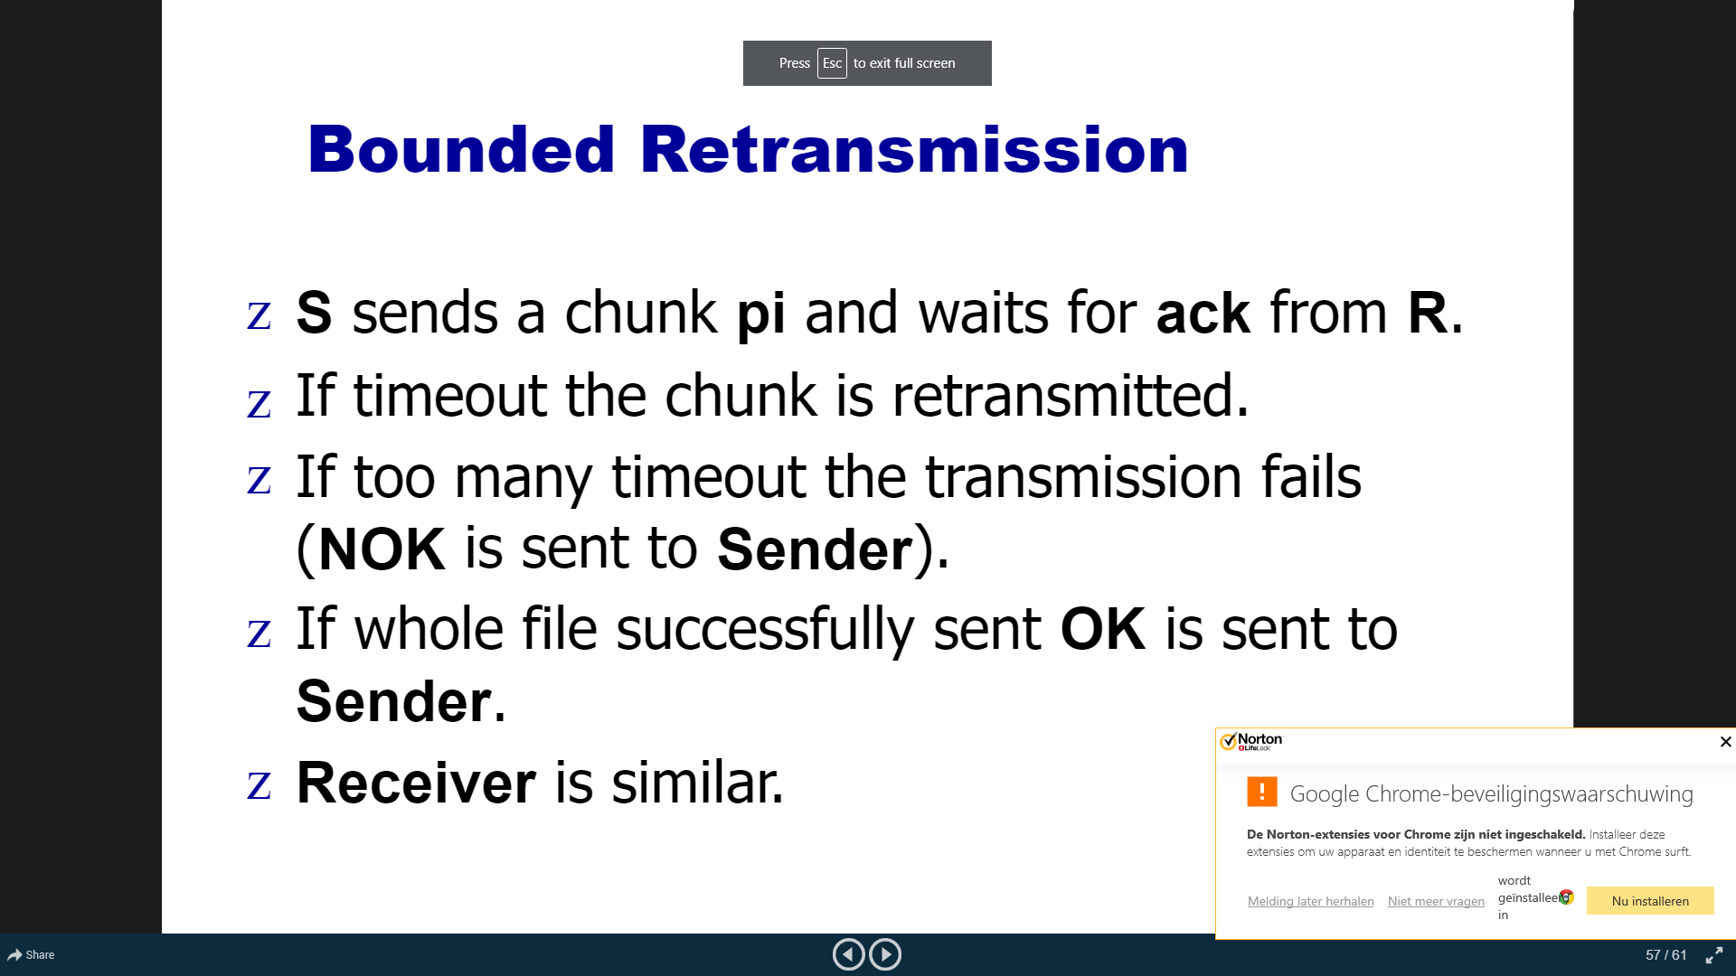

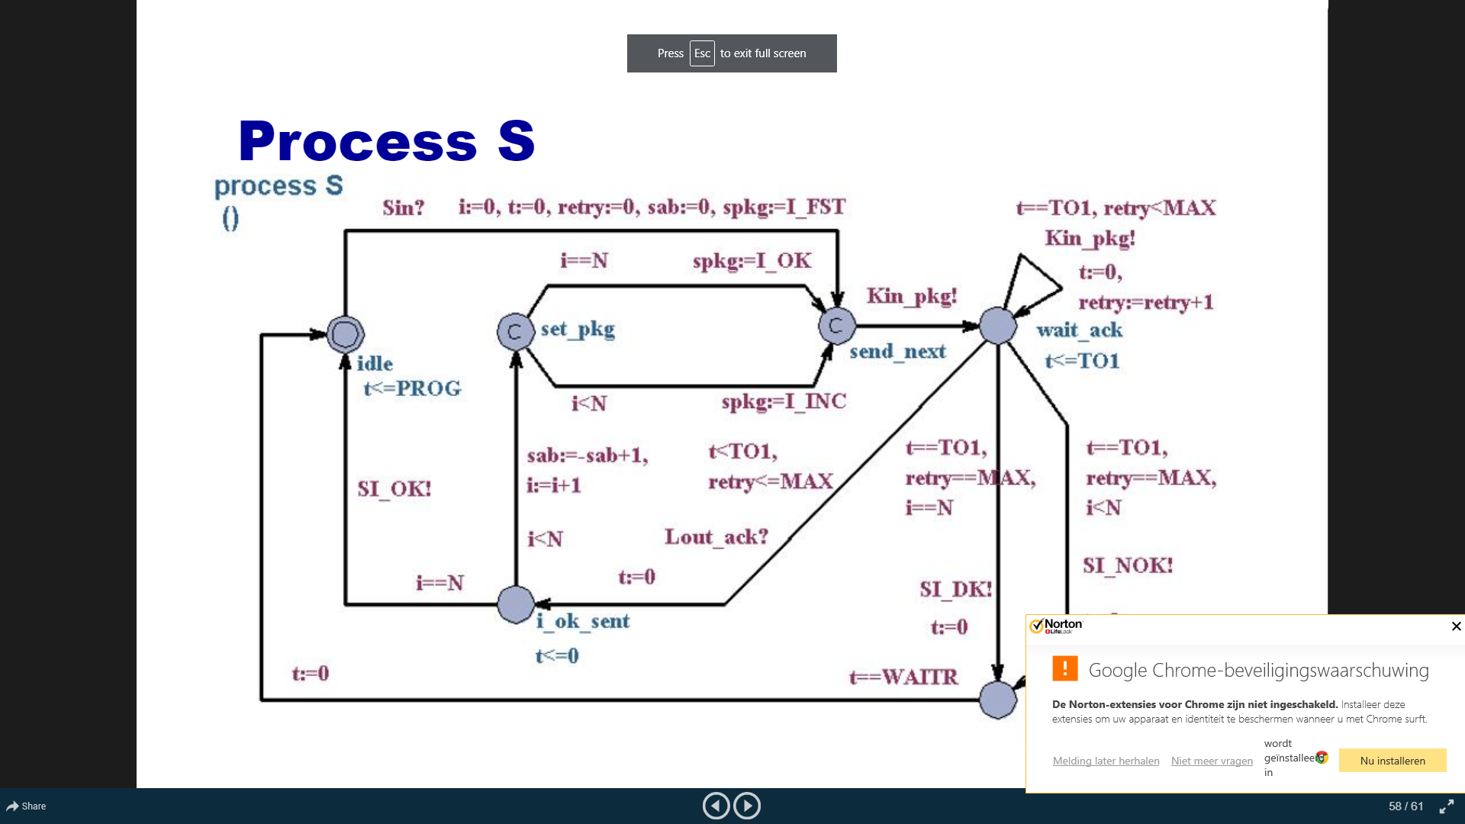

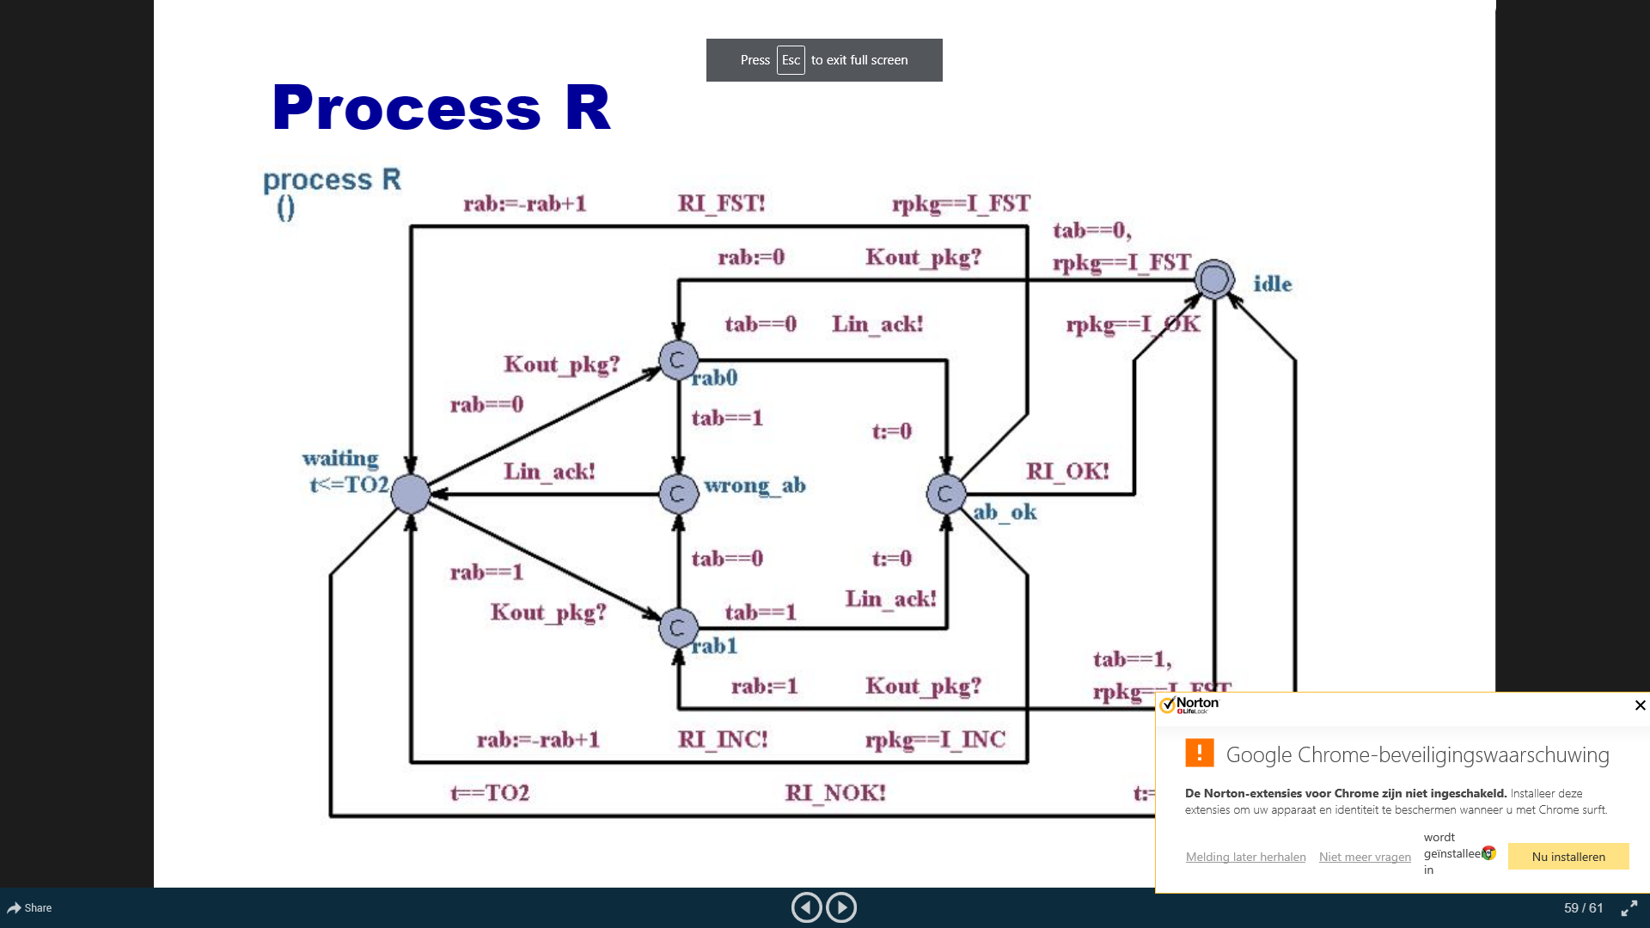

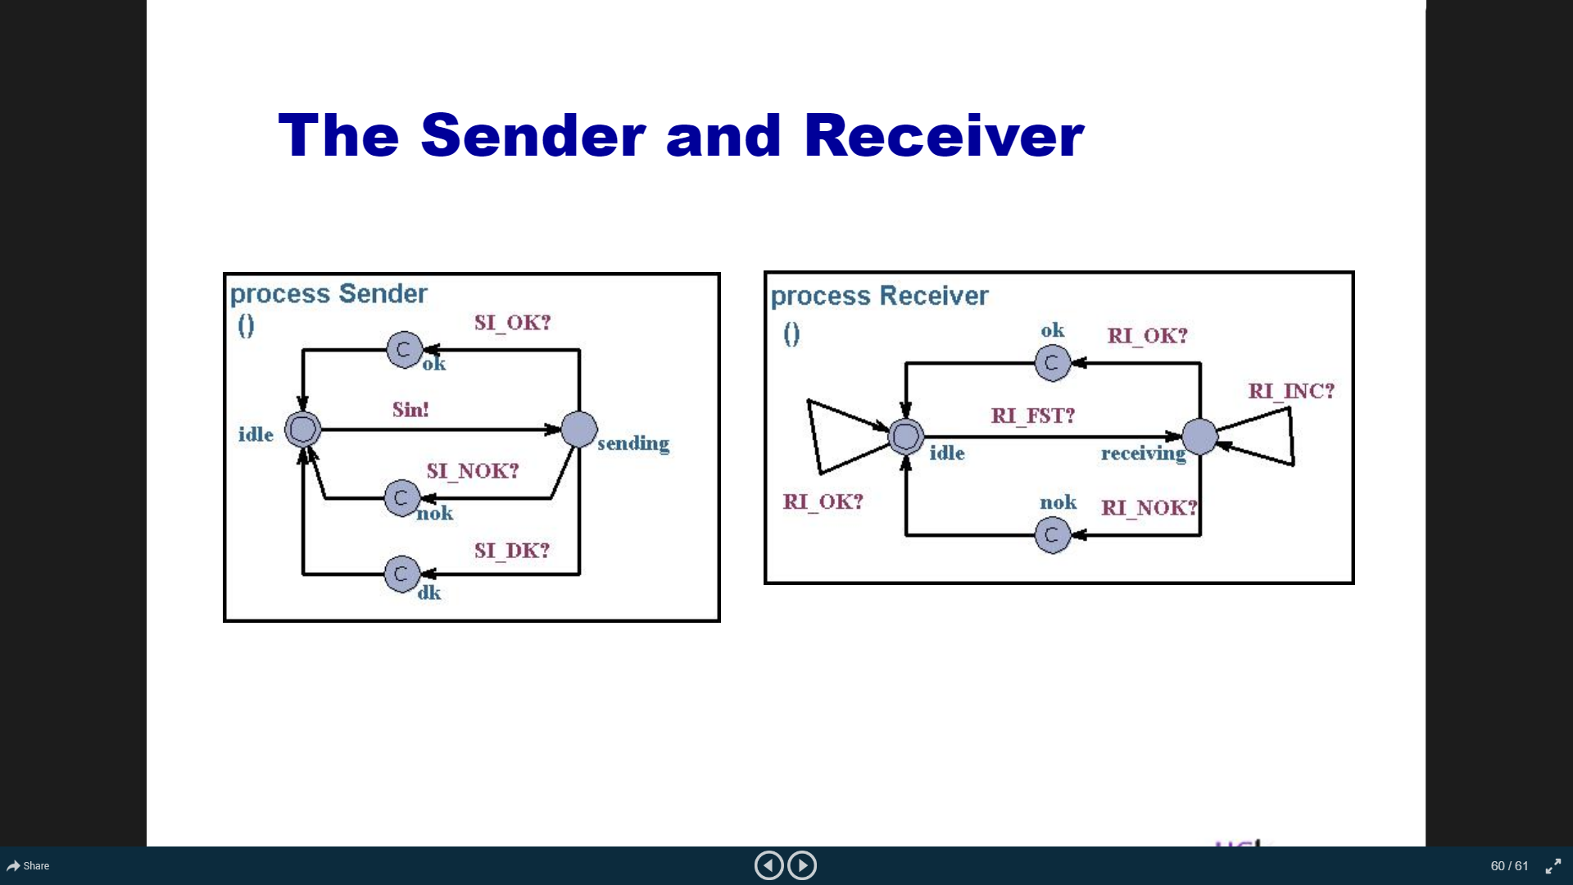

<https://www.slideserve.com/gavril/verifikation-af-realtids-systemer-i-uppaal>

<https://www.slideserve.com/osanna/cse-522-uppaal-a-model-checking-tool>

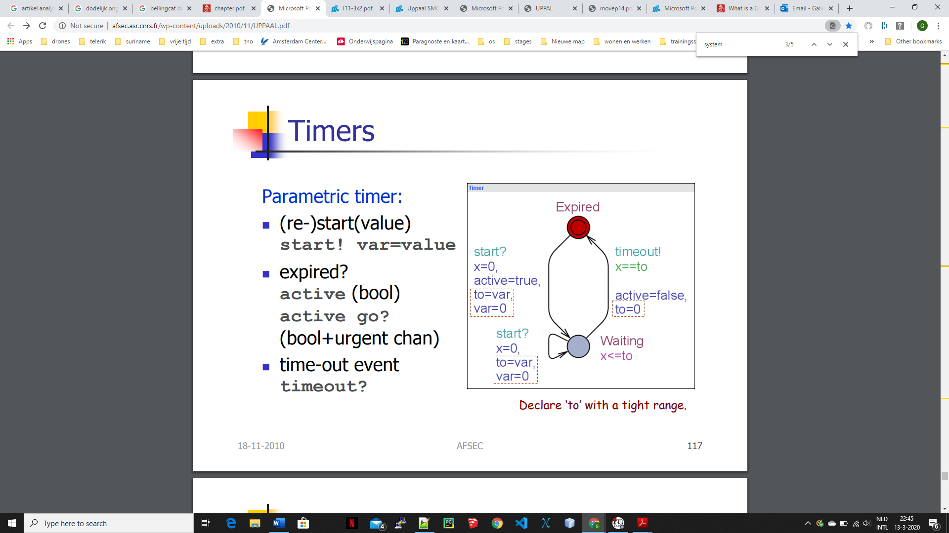

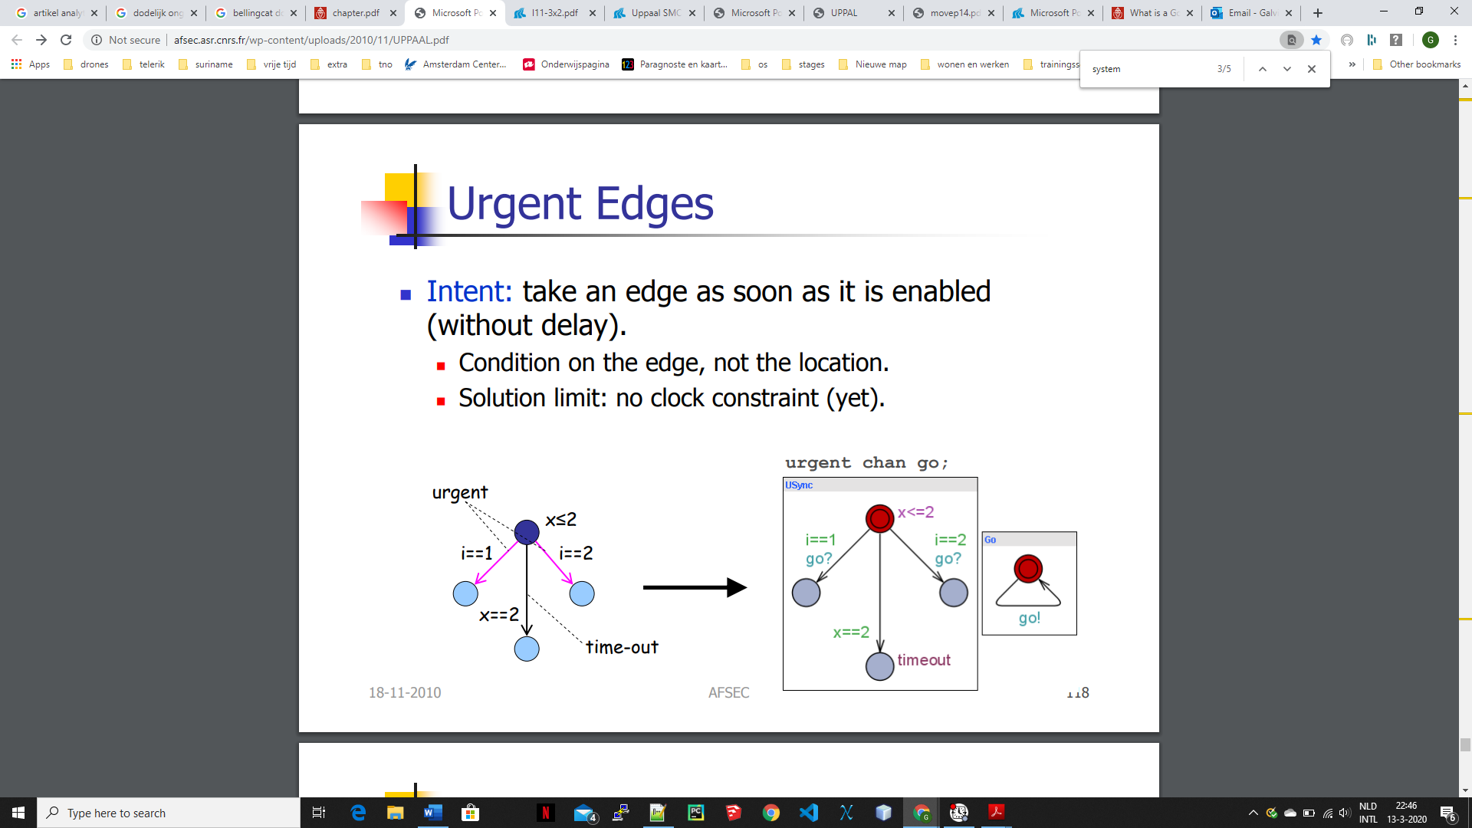

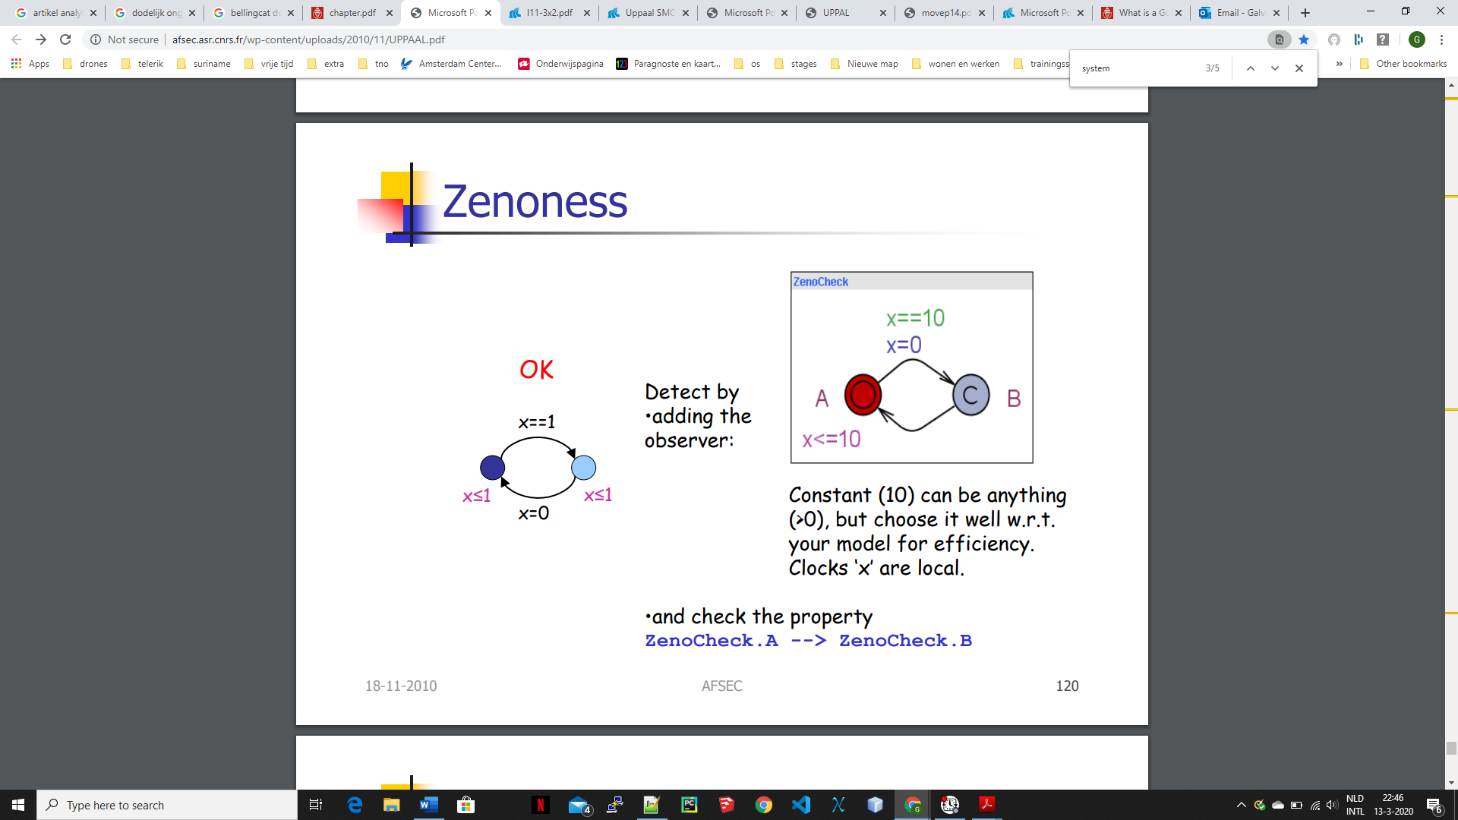<http://afsec.asr.cnrs.fr/wp-content/uploads/2010/11/UPPAAL.pdf>

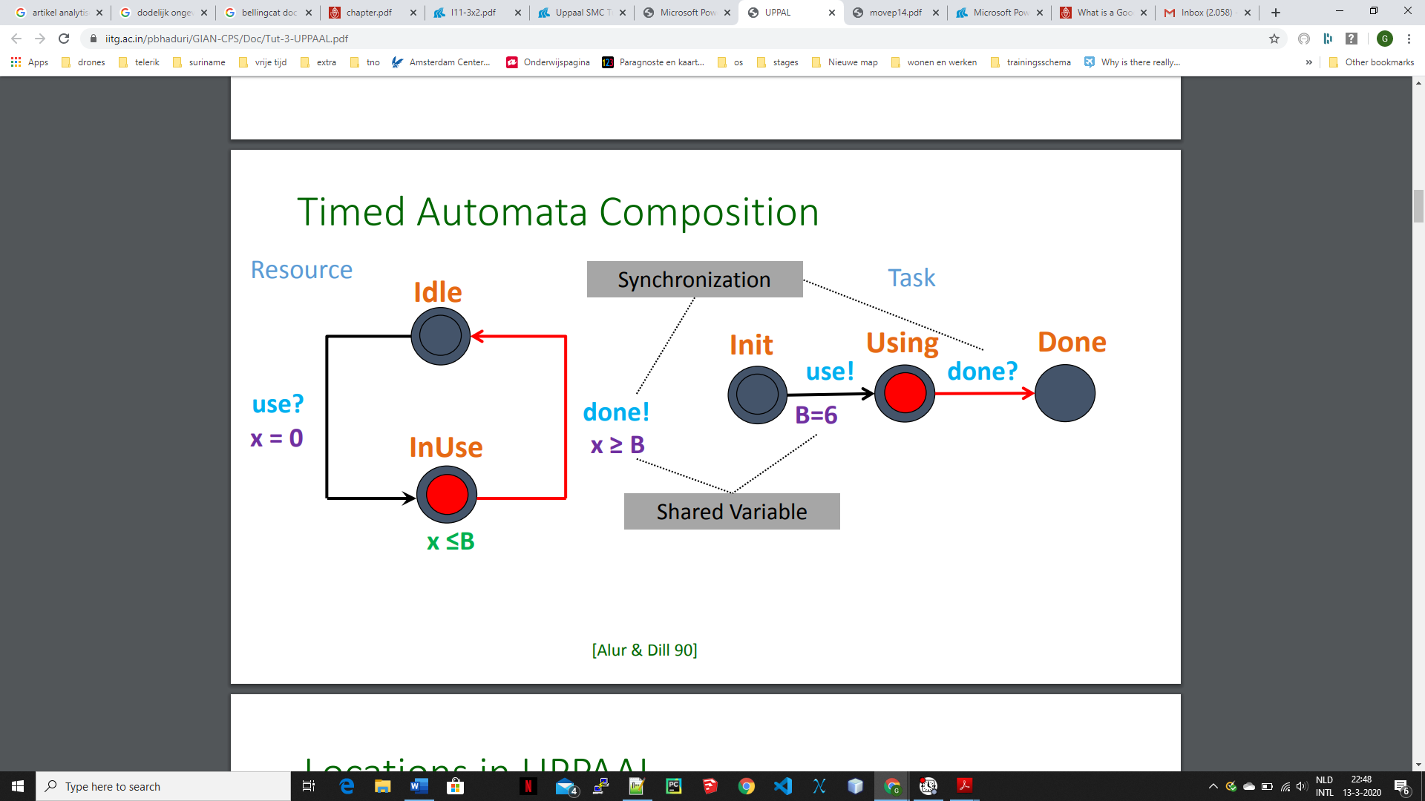

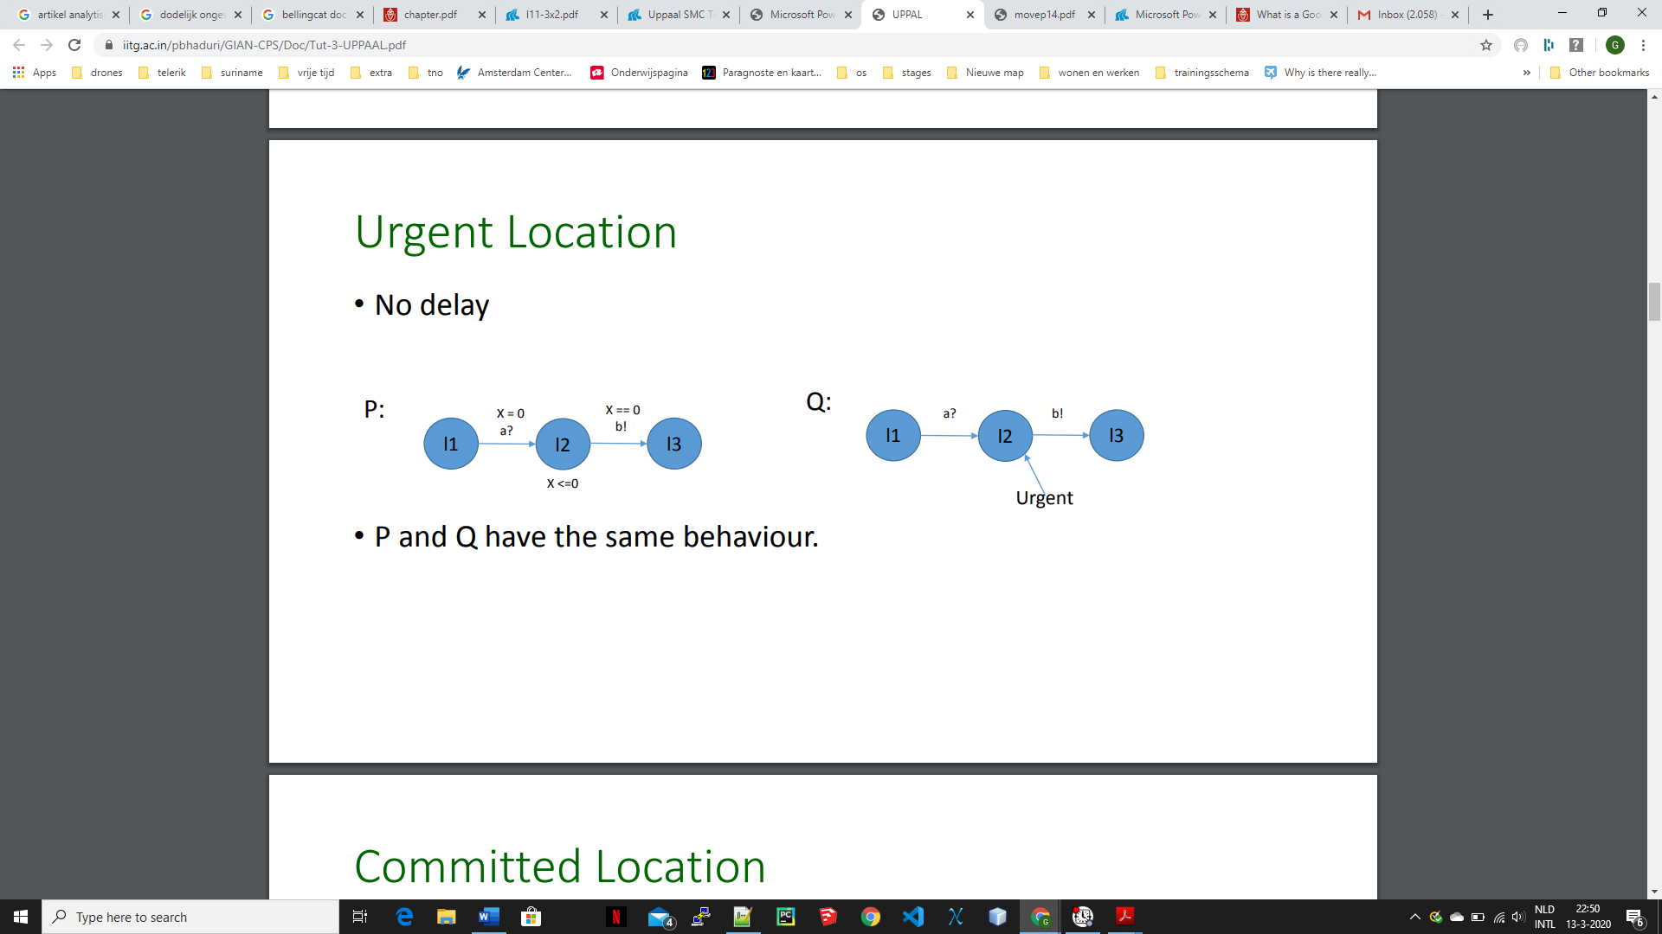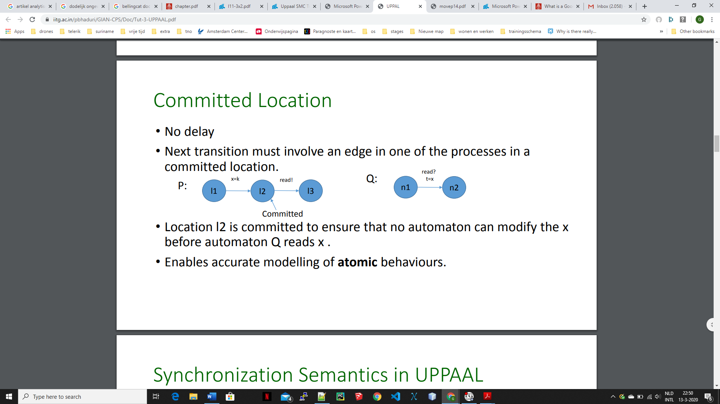

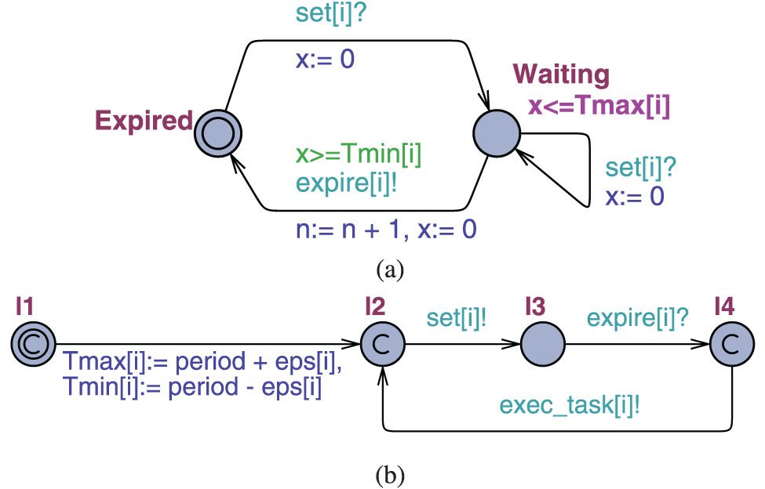

<https://www.google.com/url?sa=i&url=https%3A%2F%2Fwww.computer.org%2Fcsdl%2Fjournal%2Fts%2F2013%2F06%2Ftts2013060857%2F13rRUxjyX5N%3Flf1%3D851471428b998716105340e8874524&psig=AOvVaw1Aph4e-ntpbjgZIqedc4am&ust=1584310729171000&source=images&cd=vfe&ved=0CAIQjRxqFwoTCLCdncP_mugCFQAAAAAdAAAAABAD>

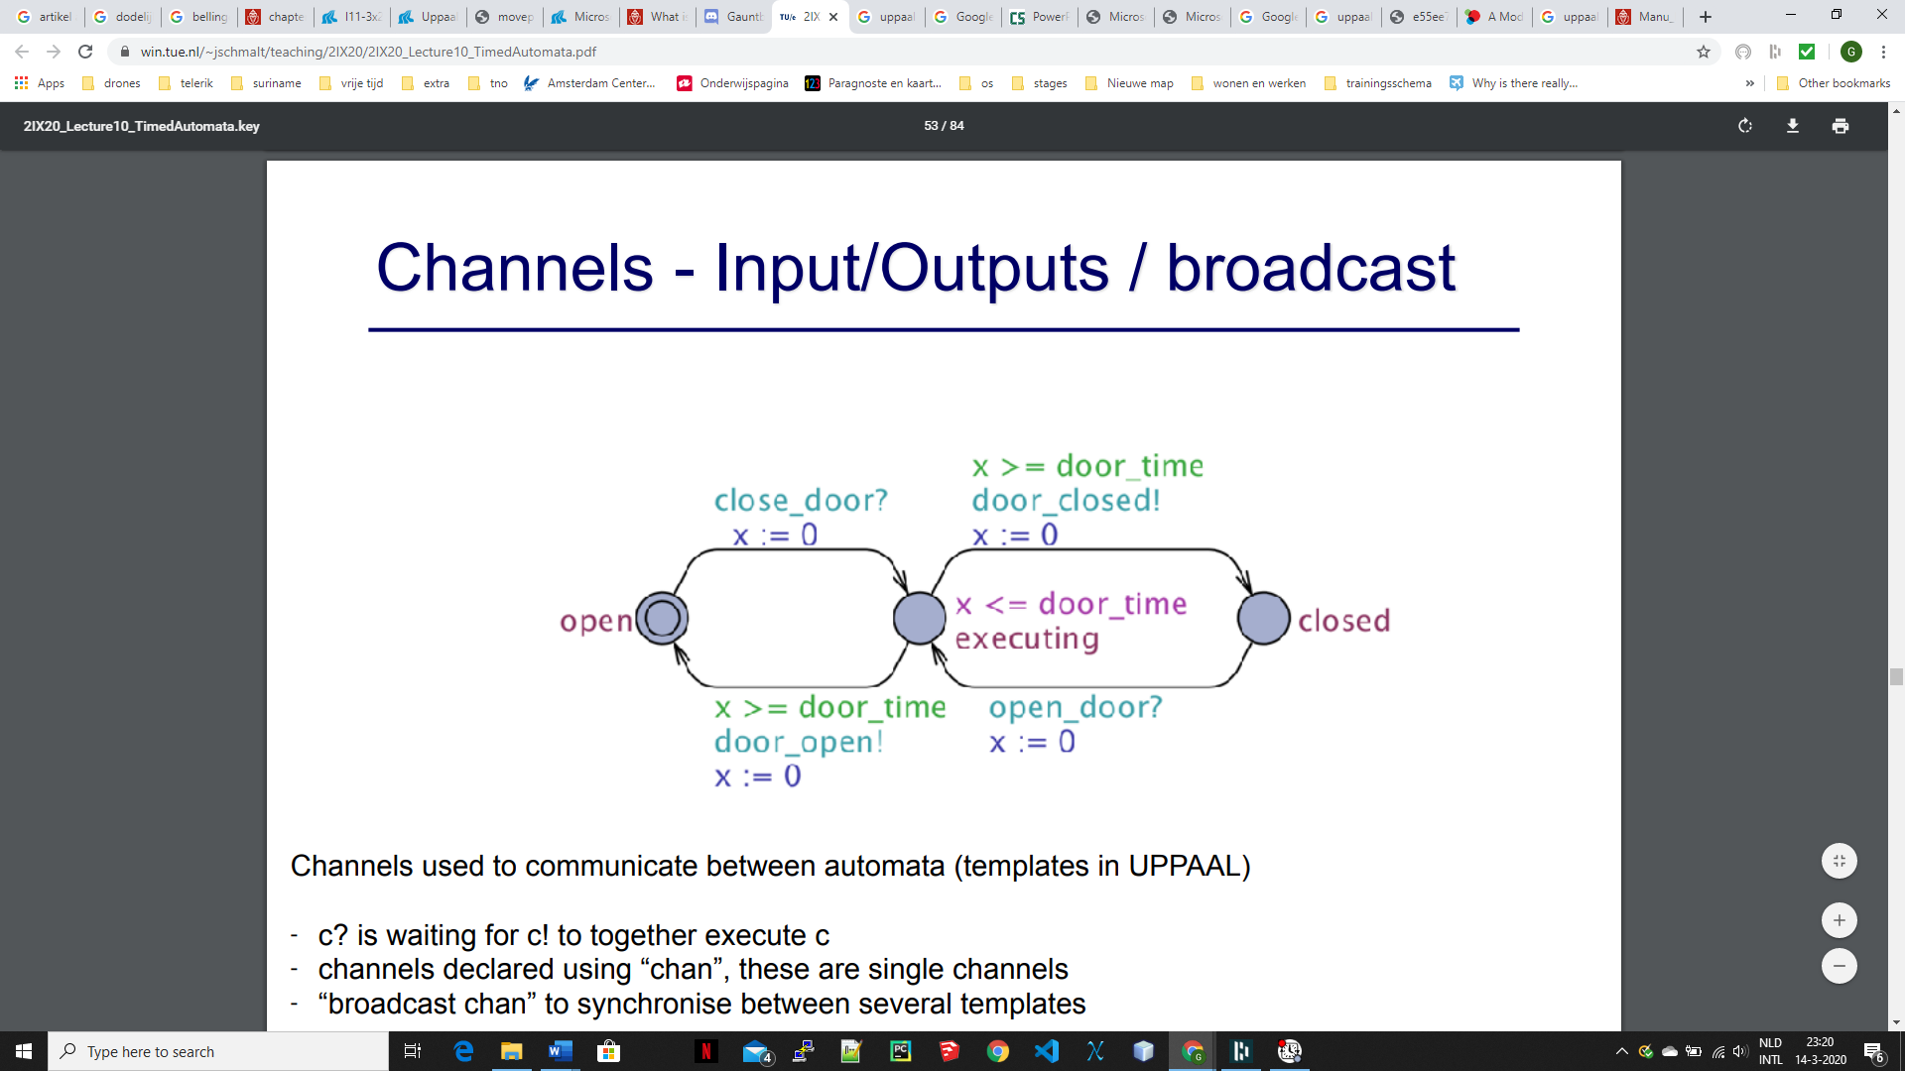

<https://www.win.tue.nl/~jschmalt/teaching/2IX20/2IX20_Lecture10_TimedAutomata.pdf>

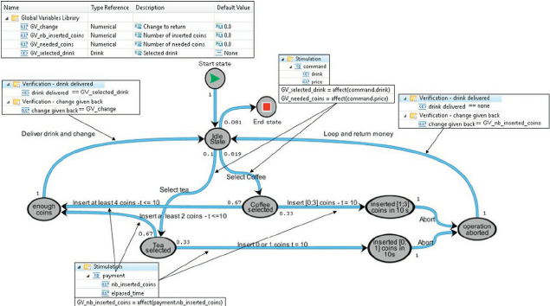

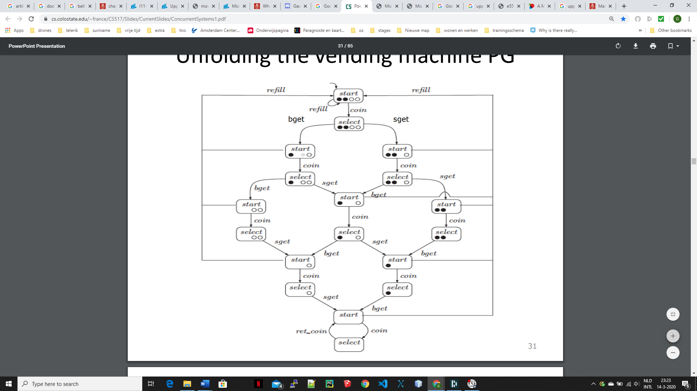

<https://www.cs.colostate.edu/~france/CS517/Slides/CurrentSlides/ConcurrentSystems1.pdf>

<http://ppedreiras.av.it.pt/resources/empse0809/slides/TheUppaalModelChecker-Julian.pdf>

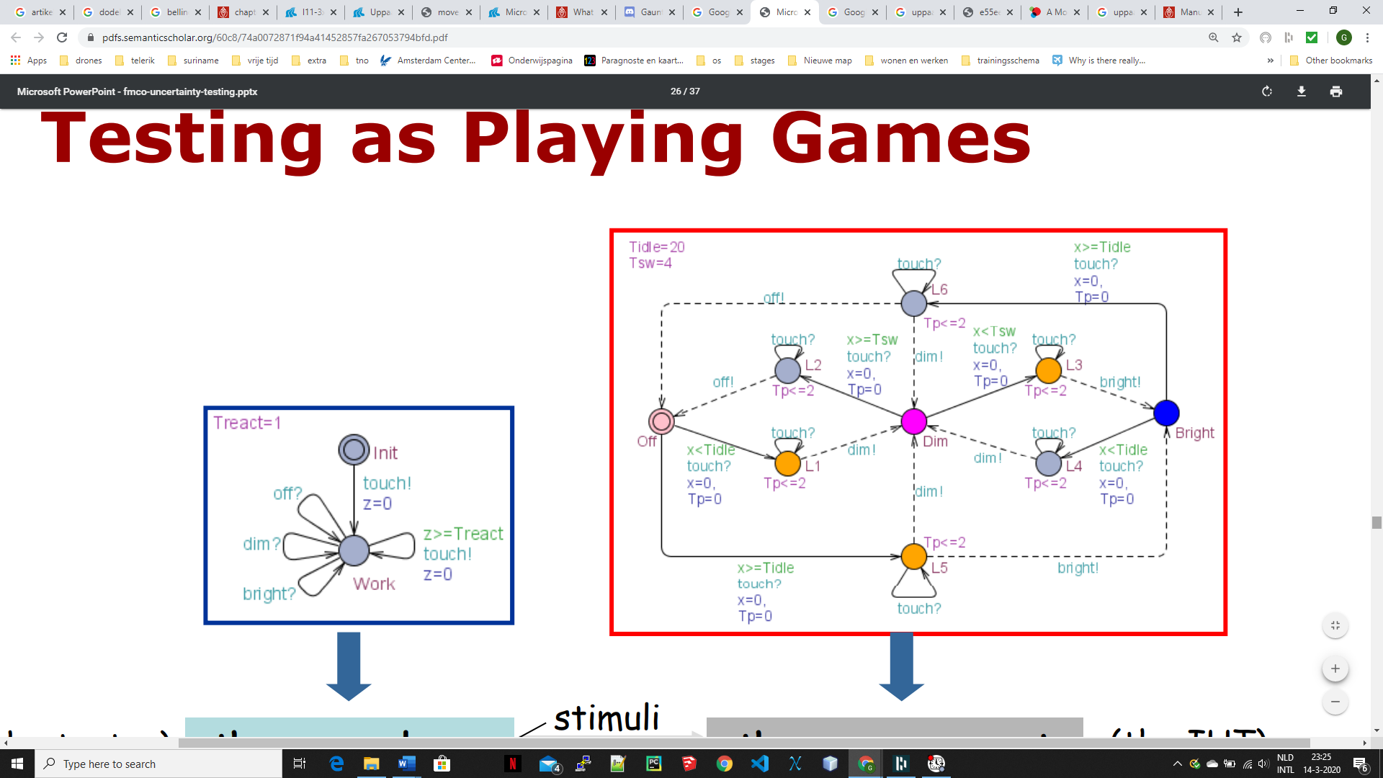

<https://pdfs.semanticscholar.org/60c8/74a0072871f94a41452857fa267053794bfd.pdf>

stratego

<https://pdfs.semanticscholar.org/aa21/e55ee7c9d75caa2d26bea8712910f5ee7ca8.pdf>

<https://www.cs.ru.nl/bachelors-theses/2012/Manu_Drijvers___3040429___Model_Checking_Tamper-Evident_Pairing.pdf>

uppaal exercises

<http://people.cs.aau.dk/~kgl/TUTOR%20Exercises/index.html>

<https://msu.edu/~hajishey/ufit.html>

<https://msu.edu/~hajishey/systemc.html>

<http://people.cs.aau.dk/~kgl/TUTOR%20Exercises/index.html>

<http://people.cs.aau.dk/~bnielsen/TOV08/ESV04/exercises/>

<http://people.cs.aau.dk/~bnielsen/TOV08/ESV04/exercises/>